Exercise 1: Inventory Management System

Why DSA Matters here: In a modern logistics warehouse handling millions of unique SKU entries, storing data sequentially in an unindexed list requires checking every single slot for updates, collapsing database efficiency from milliseconds to minutes.
Data Structure Trade-offs:
- ArrayList (Sequential Lookup): Adding an item is fast ($O(1)$), but updating or deleting requires scanning through the entire list to find the match, making retrieval an inefficient $O(N)$ operation.
- HashMap (Key-Value Direct Mapping): By mapping a unique key (like productId) directly to a storage bucket using a hashing function, retrieval, updates, and deletions bypass sequential scanning completely, dropping execution overhead to a highly optimal $O(1)$ constant time.

OUTPUT
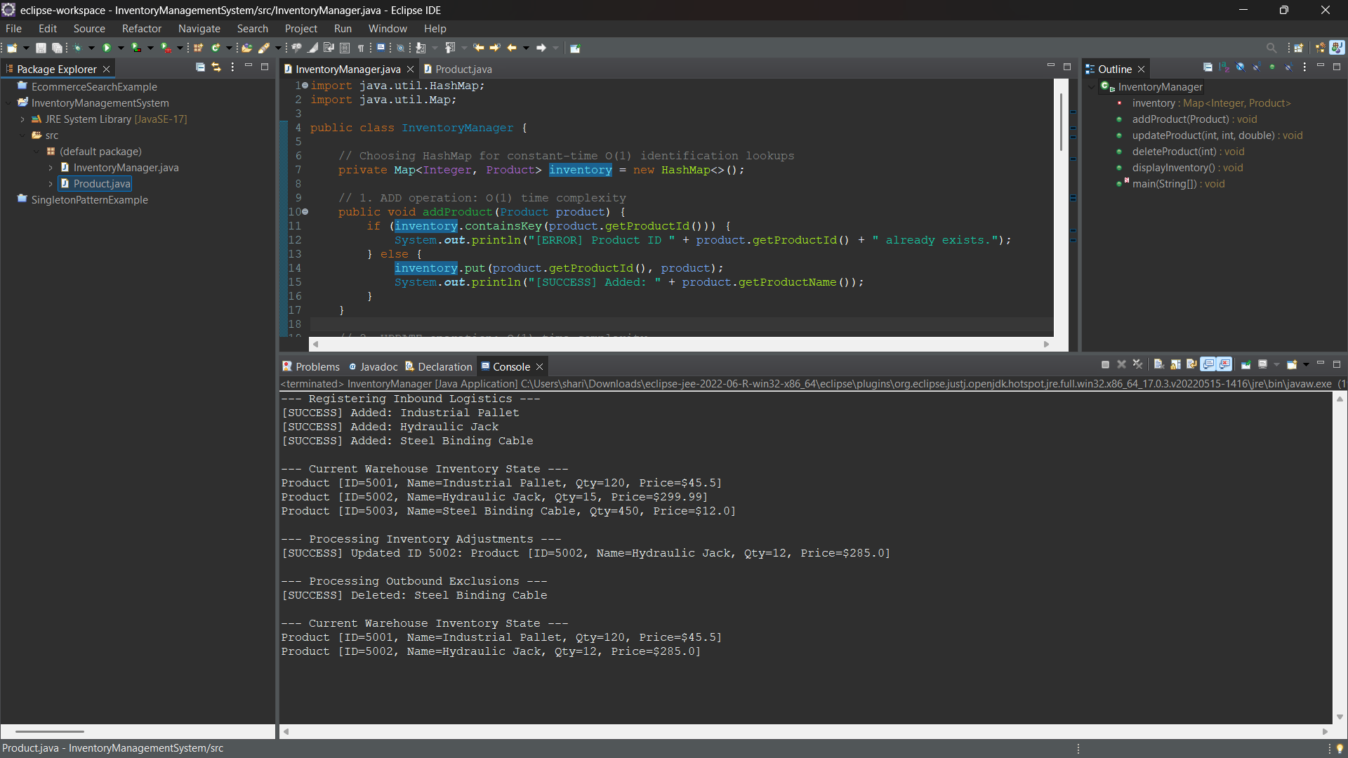

Exercise 7: Financial Forecasting

Recursion: Recursion is a programming technique where a method solves a problem by calling a smaller version of itself. Every recursive function must have a Base Case (to stop the loop) and a Recursive Case (to break the problem down).
Time Complexity:
- Unoptimized: Each recursive step branches into subsequent calls, which can cause an exponential time complexity of $O(2^N)$ or linear call space stack depths of $O(N)$.
- Optimized: By saving previously computed years into a cache (a technique called Memoization), we can eliminate recalculations, reducing the time complexity to a clean $O(N)$.

OUTPUT
